++合同产品技术文件

Accelink File No. | :
Accelink File Ver. | : | V1.0
Customer | :
Product Name | : | OM-VA-8-1550-09-0.65-LC/APC-8PD
Product Name | : | OM-VA-4-1550-09-0.65-LC/APC-4PD
Product Name | : | OM-VA-2-1550-09-0.65-LC/APC-2PD
Product Name | : | OM-VA-1-1550-09-0.65-LC/APC-1PD
<23> pages in total (Include Cover)
 | Drafter | Reviewer | Approver | Customer Confirm
Signature | 陈妍 | 张传彬
Date | 2010-8-13 | 2010-8-17

INDEX
1. Product Description 3
2. Specifications 5
3. Operating and Storage Conditions 5
4. Fiber and Connector 6
5. PIN Define 6
6. Dimension 8
7. Fiber Length and Boot Length definition 8
8. Labeling scheme 9
9. Other package requirement 9
10. Parameter Table Description 10

Document History
Ver. | Date | DESCRIPTION OF CHANGE | Comments  /Approver
1.0 | 2010-8-13 | First draft | Chen
1.1 | 2010-9-25 | Modify the I²C address of every IC | Chen

Product Specification Confirmation

1. Product Description
1.1 Product Function:
8/4/2/1 channels VOA with TAP-PD module is a custom module
1.2 Ordering information

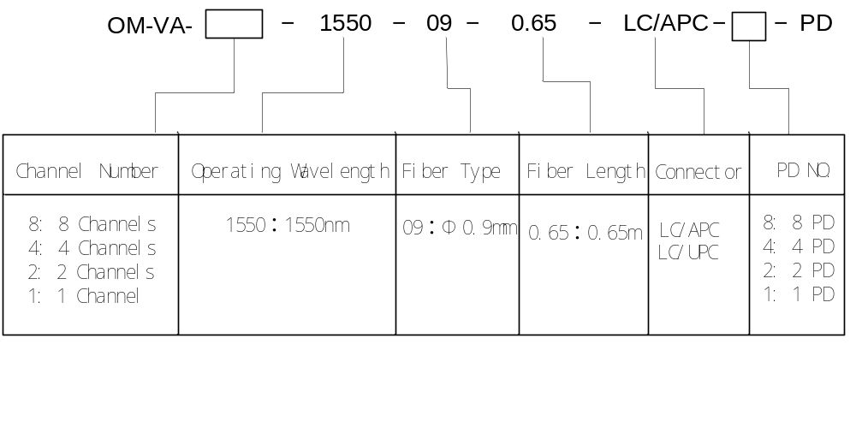
1.3 Related Product List

Customer Code | Customer P/N | Accelink Code | Accelink P/N
 |  |  | OM-VA-8-1550-09-0.65-LC/APC-8PD
 |  |  | OM-VA-4-1550-09-0.65-LC/APC-4PD
 |  |  | OM-VA-2-1550-09-0.65-LC/APC-2PD
 |  |  | OM-VA-1-1550-09-0.65-LC/APC-1PD

  - Product Configurations
8 channels module configuration diagram
Note:
For the 4 channels module, the channel number is from 1 to 4.
For the 2 channels module, the channel number is from 1 to 2.
For the 1 channel module, the channel number is 1 .

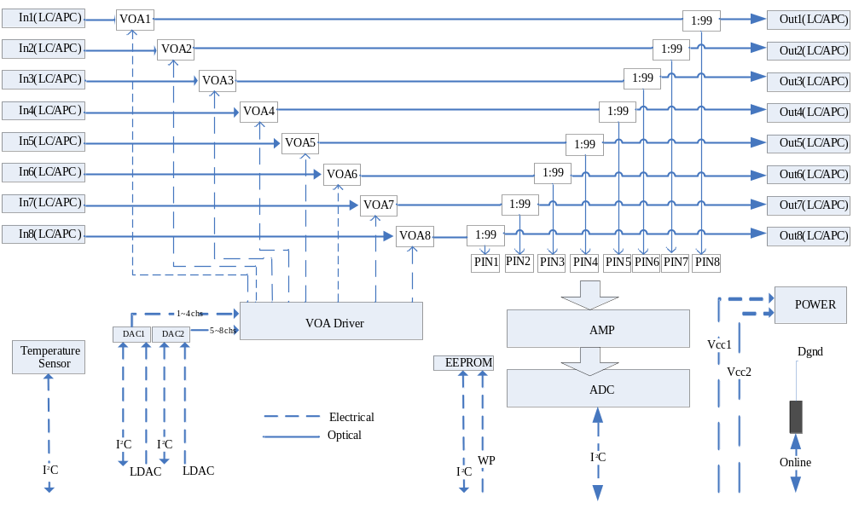

2. Specifications
No. | Parameter |  |  |  | Min | Typical | Max | Unit | Note
1 | Wavelength |  |  |  | 1528 |  | 1565 | nm
2 | Insertion Loss(With Connectors) |  |  |  |  |  | 2.0 | dB | 1
3 | Attenuation Range |  |  |  |  |  | 20 | dB
4 | Attenuation Resolution |  |  |  |  | 0.1 |  | dB | 2
5 | Attenuation Precision |  | @0~10dB |  |  |  | ±0.5 | dB | 3/4
5 |  |  | @10~15dB |  |  |  | ±0.8 | dB
6 | WDL |  | @0~10dB |  |  |  | 0.5 | dB
6 |  |  | @10~15dB |  |  |  | 0.7 | dB
7 | PDL |  | @0~10dB |  |  |  | 0.3 | dB
7 |  |  | @10~15dB |  |  |  | 0.4 | dB
8 | Optical Power Detect |  |  | IN | -30 | / | +10 | dBm
8 |  |  |  | OUT | -30 | / | +10 | dBm
9 | Optical Power Detect precision | -30dBm≤P＜-20dBm |  |  | ±0.8 |  |  | dB | 4
9 | Optical Power Detect precision | -20dBm≤P≤0dBm |  |  | ±0.5 |  |  | dB | 4
9 | Optical Power Detect precision | 0dBm＜P≤10dBm |  |  | ±0.8 |  |  | dB | 4
10 | Specifications above are in all work temperature range
Note: [1] With Connector.
[2] Guarantee by Design.
[3] Three Temperature curve: the first curve is for (-5℃--+15℃); the second curve is for (+15℃--+50℃);the third curve is for (+50℃--+65℃).
[4] The calibration data of VOA and TAP-PD is saved in EEPROM .
3. Operating and Storage Conditions
No. | Parameters | Specifications | Unit | Notes
1 | Operating temperature | -5 ~ +65 | °C
2 | Operation Humidity | 5~95 | %RH
3 | Storage Temperature | -40 ~ +85 | °C
4 | Storage Humidity | 5~95 | %RH

4. Fiber and Connector
NO. | Parameter | Specifications | Unit
1 | Fiber Pigtail(All Ports) | Compatible with SMF-28 with 900 μm  Loose Tube
2 | Fiber Length(All Ports) | 65(+/-5) | cm
3 | Connectors | LC/APC
4 | Dimension | (L)140x(W)75x(H)15 | mm
Note: Pigtail Length include connector.
5. PIN Define
Pin  Number | Name | Input/Output | Level | Function
1 | Vcc1 | Power supply |  | +5V +/-0.25V 1A
2 | Agnd | Power supply ground |  | Vcc1 Ground
3 | ROM_SCL | Input | LVTTL | I2C interface clock(EEPROM)
4 | ROM_SDA | Input/Output | LVTTL | I2C interface data (EEPROM)
5 | ROM_WP | Input | LVTTL | EEPROM
6 | Online | Output | LVTTL | Via 100Ω to DGND inside the module
7 | AD_SCL | Input | LVTTL | I2C interface clock
8 | AD_SDA | Input/Output | LVTTL | I2C interface data
9 | DA1_SCL | Input | LVTTL | DAC1 I2C interface clock
10 | DA1_SDA | Input/Output | LVTTL | DAC1 I2C interface data
11 | Vcc2 | Power supply |  | +3.3V +/-0.5V 1A
12 | Dgnd | Power supply ground |  | Vcc2 Ground
13 | LDAC1 |  | LVTTL | DAC1 Load
14 | TM_SDA | Input/Output | LVTTL | DS1624S SDA
15 | TM_SCL | Input | LVTTL | DS1624S SCL
16 | DA2_SCL | Input | LVTTL | DAC2 I2C interface clock
17 | DA2_SDA | Input/Output | LVTTL | DAC2 I2C interface data
18 | LDAC2 |  | LVTTL | DAC2 Load
Note:
[1] Two 2-Wire Interface DACs(AD5326) are used to control VOAs. FIRST DAC control 1~4 channel VOA, the address input pins of this chip are fixed as A1A0=00 by the module circuit; Second DAC control 5~8 channel VOA, the address input pins are fixed as A1A0=11;
[2] One 2-Wire Interface ADC（ADS7828） is used to convert PD analog voltage to digital value. The address input pins of this chip are fixed as A1A0=00 by the module circuit;
[3] The module Supports electrical label function. A 128k I2C CMOS Serial EEPROM(24LC128) is used to store the manufacture information and calibration tables. The address input pins of this chip are fixed as A2A1A0=000 by the module circuit;
[4] Client can do electrical label information upgrading by set the ROM_WP pin to low level;
[5] The “Module_ Online” signal is active low in the Client host board. THE Online pin output is capable of driving a load of 100Ω to DGND in the module;
[6] A digital thermometer (DS1624) provides 13-bit temperature readings which indicate the temperature of the module. The DS1624 supports a bi–directional two–wire bus and data transmission protocol. The address input pins of this chip are fixed as A2A1A0=100 by the module circuit;

The following table shows the address of I²C:
IC Type | I²C slave address  define | I²C slave address  design | I²C slave address  pin describe | Note
ADS7828 | 1.0.0.1.0.A1.A0 | 1.0.0.1.0.0.0 | A1=DGND,A0=DGND
AD5326(-1) | 0.0.0.1.1.A1.A0 | 0.0.0.1.1.0.0 | A1=DGND,A0=DGND
AD5326(-2) | 0.0.0.1.1.A1.A0 | 0.0.0.1.1.1.1 | A1=VDD,A0=VDD
DS1624S | 1.0.0.1.A2.A1.A0 | 1.0.0.1.1.0.0 | A2=VDD,A1=DGND,A0=DGND
24LC128 | 1.0.1.0.A2.A1.A0 | 1.0.1.0.0.0.0 | A2=DGND,A1=DGND,A0=DGND

5.2. the square post header mates with module socket :
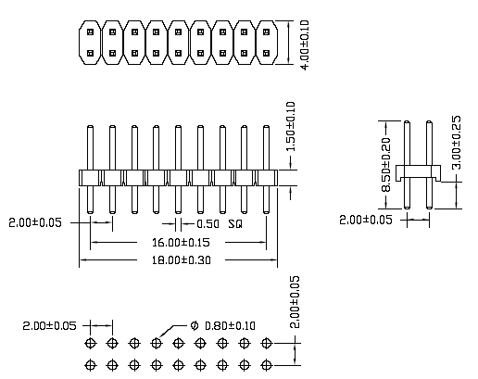

6. Dimension
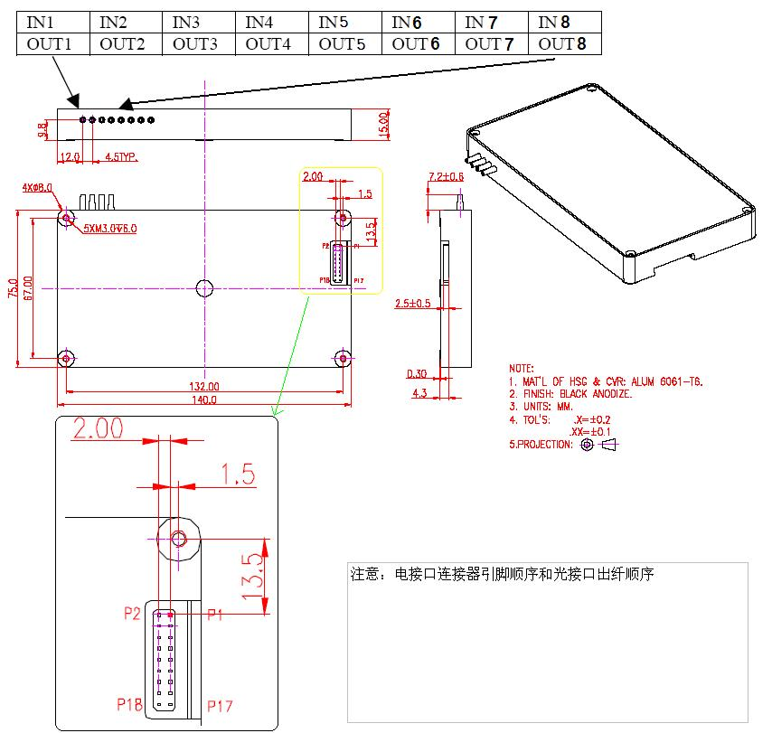
7. Fiber Length and Boot Length definition

Body

Fiber length

≤5mm

8. Labeling scheme

  - On Connector

LABEL LOCATION
Label on Boot
Boot
XX
LABEL DRAWING

XX

XX

XX

XX
Wrap Area
Text Area
6.0 mm
16.0 mm

XX = IN1, OUT1, IN2, OUT2, IN3, OUT3, IN4, OUT4, IN5, OUT5, IN6, OUT6, IN7, OUT7, IN8, OUT8

9. Other package requirement
A. ESD Packing
B. Heat-Proof Requirement

10. Parameter Table Description
The following parameter table will be accessible via I2C interface(ROM_SCL,ROM_SDA).
Data Field Desciption | Address Range(Hex) | Field Size | Data Type | Data Field contents
Part Number | 0X0000-0X0013 | 20 | ASCII | LVOA809010000
Date of manufacture | 0X0014-0X0019 | 6 | ASCII | YYMMDD
Checksum | 0X001A-0X001D | 4 | Bin | For Bytes 0X0000-0X19FF,Note1
Reserved | 0X001E-0X002F | 2 | Hex | 0x00
INT1->OUT1 Insertion Loss | 0X0030-0X0033 | 4 | Hex | Note3
INT2->OUT2 Insertion Loss | 0X0034-0X0037 | 4 | Hex | Note3
INT3->OUT3 Insertion Loss | 0X0038-0X003B | 4 | Hex | Note3
INT4->OUT4 Insertion Loss | 0X003C-0X003F | 4 | Hex | Note3
INT5->OUT5 Insertion Loss | 0X0040-0X0043 | 4 | Hex | Note3
INT6->OUT6 Insertion Loss | 0X0044-0X0047 | 4 | Hex | Note3
INT7->OUT7 Insertion Loss | 0X0048-0X004B | 4 | Hex | Note3
INT8->OUT8 Insertion Loss | 0X004C-0X004F | 4 | Hex | Note3
Minimum attenuation of VOA1 | 0X0050-0X0053 | 4 | Hex | Note4
Maximal attenuation of VOA1 | 0X0054-0X0057 | 4 | Hex | Note4
Minimum attenuation of VOA2 | 0X0058-0X005B | 4 | Hex | Note4
Maximal attenuation of VOA2 | 0X005C-0X005F | 4 | Hex | Note4
Minimum attenuation of VOA3 | 0X0060-0X0063 | 4 | Hex | Note4
Maximal attenuation of VOA3 | 0X0064-0X0067 | 4 | Hex | Note4
Minimum attenuation of VOA4 | 0X0068-0X006B | 4 | Hex | Note4
Maximal attenuation of VOA4 | 0X006C-0X006F | 4 | Hex | Note4
Minimum attenuation of VOA5 | 0X0070-0X0073 | 4 | Hex | Note4
Maximal attenuation of VOA5 | 0X0074-0X0077 | 4 | Hex | Note4
Minimum attenuation of VOA6 | 0X0078-0X007B | 4 | Hex | Note4
Maximal attenuation of VOA6 | 0X007C-0X007F | 4 | Hex | Note4
Minimum attenuation of VOA7 | 0X0080-0X0083 | 4 | Hex | Note4
Maximal attenuation of VOA7 | 0X0084-0X0087 | 4 | Hex | Note4
Minimum attenuation of VOA8 | 0X0088-0X008B | 4 | Hex | Note4
Maximal attenuation of VOA8 | 0X008C-0X008F | 4 | Hex | Note4
First temperature demarcation point | 0X0090-0X0093 | 4 | Hex | Note5,Note2
Second temperature demarcation point | 0X0094-0X0097 | 4 | Hex | Note5,Note2
Reserved | 0X0098-0X01FF | 360 | Hex | 0x00
VOA Low temperature calibration data
VOA1 attenuation in dB value 1 | 0X0200-0X0203 | 4 | Hex | Note6
VOA1 attenuation in DAC value 1 | 0X0204-0X0207 | 4 | Hex
VOA1 attenuation in dB value 2 | 0X0208-0X020B | 4 | Hex | Note6
VOA1 attenuation in DAC value 2 | 0X020C-0X020F | 4 | Hex
VOA1 attenuation in dB value 3 | 0X0210-0X0213 | 4 | Hex | Note6
VOA1 attenuation in DAC value 3 | 0X0214-0X0217 | 4 | Hex
… … | … … | … … | Hex
VOA1 attenuation in dB value 30 | 0X02E8-0X02EB | 4 | Hex | Note6
VOA1 attenuation in DAC value 30 | 0X02EC-0X02EF | 4 | Hex
Reserved | 0X02F0-0X02FF | 16 | Hex | 0x00
VOA2 attenuation in dB value 1 | 0X0300-0X0303 | 4 | Hex | Note6
VOA2 attenuation in DAC value 1 | 0X0304-0X0307 | 4 | Hex
VOA2 attenuation in dB value 2 | 0X0308-0X030B | 4 | Hex | Note6
VOA2 attenuation in DAC value 2 | 0X030C-0X030F | 4 | Hex
VOA2 attenuation in dB value 3 | 0X0310-0X0313 | 4 | Hex | Note6
VOA2 attenuation in DAC value 3 | 0X0314-0X0317 | 4 | Hex
… … | … … | … … | Hex
VOA2 attenuation in dB value 30 | 0X03E8-0X03EB | 4 | Hex | Note6
VOA2 attenuation in DAC value 30 | 0X03EC-0X03EF | 4 | Hex
Reserved | 0X03F0-0X03FF | 16 | Hex | 0x00
VOA3 attenuation in dB value 1 | 0X0400-0X0403 | 4 | Hex | Note6
VOA3 attenuation in DAC value 1 | 0X0404-0X0407 | 4 | Hex
VOA3 attenuation in dB value 2 | 0X0408-0X040B | 4 | Hex | Note6
VOA3 attenuation in DAC value 2 | 0X040C-0X040F | 4 | Hex
VOA3 attenuation in dB value 3 | 0X0410-0X0413 | 4 | Hex | Note6
VOA3 attenuation in DAC value 3 | 0X0414-0X0417 | 4 | Hex
… … | … … | … … | Hex
VOA3 attenuation in dB value 30 | 0X04E8-0X04EB | 4 | Hex | Note6
VOA3 attenuation in DAC value 30 | 0X04EC-0X04EF | 4 | Hex
Reserved | 0X04F0-0X04FF | 16 | Hex | 0x00
… … | … … | … … | Hex
… … | … … | … … | Hex
VOA8 attenuation in dB value 1 | 0X0900-0X0903 | 4 | Hex | Note6
VOA8 attenuation in DAC value 1 | 0X0904-0X0907 | 4 | Hex
VOA8 attenuation in dB value 2 | 0X0908-0X090B | 4 | Hex | Note6
VOA8 attenuation in DAC value 2 | 0X090C-0X090F | 4 | Hex
VOA8 attenuation in dB value 3 | 0X0910-0X0913 | 4 | Hex | Note6
VOA8 attenuation in DAC value 3 | 0X0914-0X0917 | 4 | Hex
… … | … … | … … | Hex
VOA8 attenuation in dB value 30 | 0X09E8-0X09EB | 4 | Hex | Note6
VOA8 attenuation in DAC value 30 | 0X09EC-0X09EF | 4 | Hex
Reserved | 0X09F0-0X09FF | 16 | Hex
VOA Room temperature calibration data
VOA1 attenuation in dB value 1 | 0X0A00-0X0A03 | 4 | Hex | Note6
VOA1 attenuation in DAC value 1 | 0X0A04-0X0A07 | 4 | Hex
VOA1 attenuation in dB value 2 | 0X0A08-0X0A0B | 4 | Hex | Note6
VOA1 attenuation in DAC value 2 | 0X0A0C-0X0A0F | 4 | Hex
VOA1 attenuation in dB value 3 | 0X0A10-0X0A13 | 4 | Hex | Note6
VOA1 attenuation in DAC value 3 | 0X0A14-0X0A17 | 4 | Hex
… … | … … | … … | Hex
VOA1 attenuation in dB value 30 | 0X0AE8-0X0AEB | 4 | Hex | Note6
VOA1 attenuation in DAC value 30 | 0X0AEC-0X0AEF | 4 | Hex
Reserved | 0X0AF0-0X0AFF | 16 | Hex | 0x00
VOA2 attenuation in dB value 1 | 0X0B00-0X0B03 | 4 | Hex | Note6
VOA2 attenuation in DAC value 1 | 0X0B04-0X0B07 | 4 | Hex
VOA2 attenuation in dB value 2 | 0X0B08-0X0B0B | 4 | Hex | Note6
VOA2 attenuation in DAC value 2 | 0X0B0C-0X0B0F | 4 | Hex
VOA2 attenuation in dB value 3 | 0X0B10-0X0B13 | 4 | Hex | Note6
VOA2 attenuation in DAC value 3 | 0X0B14-0X0B17 | 4 | Hex
… … | … … | … … | Hex
VOA2 attenuation in dB value 30 | 0X0BE8-0X0BEB | 4 | Hex | Note6
VOA2 attenuation in DAC value 30 | 0X0BEC-0X0BEF | 4 | Hex
Reserved | 0X0BF0-0X0BFF | 16 | Hex | 0x00
VOA3 attenuation in dB value 1 | 0X0C00-0X0C03 | 4 | Hex | Note6
VOA3 attenuation in DAC value 1 | 0X0C04-0X0C07 | 4 | Hex
VOA3 attenuation in dB value 2 | 0X0C08-0X0C0B | 4 | Hex | Note6
VOA3 attenuation in DAC value 2 | 0X0C0C-0X0C0F | 4 | Hex
VOA3 attenuation in dB value 3 | 0X0C10-0X0C13 | 4 | Hex | Note6
VOA3 attenuation in DAC value 3 | 0X0C14-0X0C17 | 4 | Hex
… … | … … | … … | Hex
VOA3 attenuation in dB value 30 | 0X0CE8-0X0CEB | 4 | Hex | Note6
VOA3 attenuation in DAC value 30 | 0X0CEC-0X0CEF | 4 | Hex
Reserved | 0X0CF0-0X0CFF | 16 | Hex | 0x00
… … | … … | … … | Hex
… … | … … | … … | Hex
VOA8 attenuation in dB value 1 | 0X1100-0X1103 | 4 | Hex | Note6
VOA8 attenuation in DAC value 1 | 0X1104-0X1107 | 4 | Hex
VOA8 attenuation in dB value 2 | 0X1108-0X110B | 4 | Hex | Note6
VOA8 attenuation in DAC value 2 | 0X110C-0X110F | 4 | Hex
VOA8 attenuation in dB value 3 | 0X1110-0X1113 | 4 | Hex | Note6
VOA8 attenuation in DAC value 3 | 0X1114-0X1117 | 4 | Hex
… … | … … | … … | Hex
VOA8 attenuation in dB value 30 | 0X11E8-0X11EB | 4 | Hex | Note6
VOA8 attenuation in DAC value 30 | 0X11EC-0X11EF | 4 | Hex
Reserved | 0X11F0-0X11FF | 16 | Hex | 0x00
VOA High temperature calibration data
VOA1 attenuation in dB value 1 | 0X1200-0X1203 | 4 | Hex | Note6
VOA1 attenuation in DAC value 1 | 0X1204-0X1207 | 4 | Hex
VOA1 attenuation in dB value 2 | 0X1208-0X120B | 4 | Hex | Note6
VOA1 attenuation in DAC value 2 | 0X120C-0X120F | 4 | Hex
VOA1 attenuation in dB value 3 | 0X1210-0X1213 | 4 | Hex | Note6
VOA1 attenuation in DAC value 3 | 0X1214-0X1217 | 4 | Hex
… … | … … | … … | Hex
VOA1 attenuation in dB value 30 | 0X12E8-0X12EB | 4 | Hex | Note6
VOA1 attenuation in DAC value 30 | 0X12EC-0X12EF | 4 | Hex
Reserved | 0X12F0-0X12FF | 16 | Hex | 0x00
VOA2 attenuation in dB value 1 | 0X1300-0X1303 | 4 | Hex | Note6
VOA2 attenuation in DAC value 1 | 0X1304-0X1307 | 4 | Hex
VOA2 attenuation in dB value 2 | 0X1308-0X130B | 4 | Hex | Note6
VOA2 attenuation in DAC value 2 | 0X130C-0X130F | 4 | Hex
VOA2 attenuation in dB value 3 | 0X1310-0X1313 | 4 | Hex | Note6
VOA2 attenuation in DAC value 3 | 0X1314-0X1317 | 4 | Hex
… … | … … | … … | Hex
VOA2 attenuation in dB value 30 | 0X13E8-0X13EB | 4 | Hex | Note6
VOA2 attenuation in DAC value 30 | 0X13EC-0X13EF | 4 | Hex
Reserved | 0X13F0-0X13FF | 16 | Hex | 0x00
VOA3 attenuation in dB value 1 | 0X1400-0X1403 | 4 | Hex | Note6
VOA3 attenuation in DAC value 1 | 0X1404-0X1407 | 4 | Hex
VOA3 attenuation in dB value 2 | 0X1408-0X140B | 4 | Hex | Note6
VOA3 attenuation in DAC value 2 | 0X140C-0X140F | 4 | Hex
VOA3 attenuation in dB value 3 | 0X1410-0X1413 | 4 | Hex | Note6
VOA3 attenuation in DAC value 3 | 0X1414-0X1417 | 4 | Hex
… … | … … | … … | Hex
VOA3 attenuation in dB value 30 | 0X14E8-0X14EB | 4 | Hex | Note6
VOA3 attenuation in DAC value 30 | 0X14EC-0X14EF | 4 | Hex
Reserved | 0X14F0-0X14FF | 16 | Hex | 0x00
… … | … … | … … | Hex
… … | … … | … … | Hex
VOA8 attenuation in dB value 1 | 0X1900-0X1903 | 4 | Hex | Note6
VOA8 attenuation in DAC value 1 | 0X1904-0X1907 | 4 | Hex
VOA8 attenuation in dB value 2 | 0X1908-0X190B | 4 | Hex | Note6
VOA8 attenuation in DAC value 2 | 0X190C-0X190F | 4 | Hex
VOA8 attenuation in dB value 3 | 0X1910-0X1913 | 4 | Hex | Note6
VOA8 attenuation in DAC value 3 | 0X1914-0X1917 | 4 | Hex
… … | … … | … … | Hex
VOA8 attenuation in dB value 30 | 0X19E8-0X19EB | 4 | Hex | Note6
VOA8 attenuation in DAC value 30 | 0X19EC-0X19EF | 4 | Hex
Reserved | 0X19F0-0X19FF | 16 | Hex | 0x00
PIN Low temperature calibration data
PIN1 optical power in dB value 1 | 0X2000-0X2003 | 4 | Hex | Note7
PIN1 optical power in ADC value 1 | 0X2004-0X2007 | 4 | Hex
PIN1 optical power in dB value 2 | 0X2008-0X200B | 4 | Hex | Note7
PIN1 optical power in ADC value 2 | 0X200C-0X200F | 4 | Hex
PIN1 optical power in dB value 3 | 0X2010-0X2013 | 4 | Hex | Note7
PIN1 optical power in ADC value 3 | 0X2014-0X2017 | 4 | Hex
… … | … … | … … | Hex
PIN1 optical power in dB value 40 | 0X2138-0X213B | 4 | Hex | Note7
PIN1 optical power in ADC value 40 | 0X213C-0X213F | 4 | Hex
Reserved | 0X2140-0X214F | 16 | Hex | 0x00
PIN2 optical power in dB value 1 | 0X2150-0X2153 | 4 | Hex | Note7
PIN2 optical power in ADC value 1 | 0X2154-0X2157 | 4 | Hex
PIN2 optical power in dB value 2 | 0X2158-0X215B | 4 | Hex | Note7
PIN2 optical power in ADC value 2 | 0X215C-0X215F
PIN2 optical power in dB value 3 | 0X2160-0X2163 | 4 | Hex | Note7
PIN2 optical power in ADC value 3 | 0X2164-0X2167 | 4 | Hex
… … | … … | … … | Hex
PIN2 optical power in dB value 40 | 0X2288-0X228B | 4 | Hex | Note7
PIN2 optical power in ADC value 40 | 0X228C-0X228F | 4 | Hex
Reserved | 0X2290-0X229F | 16 | Hex | 0x00
PIN3 optical power in dB value 1 | 0X22A0-0X22A3 | 4 | Hex | Note7
PIN3 optical power in ADC value 1 | 0X22A4-0X22A7 | 4 | Hex
PIN3 optical power in dB value 2 | 0X22A8-0X22AB | 4 | Hex | Note7
PIN3 optical power in ADC value 2 | 0X22AC-0X22AF
PIN3 optical power in dB value 3 | 0X22B0-0X22B3 | 4 | Hex | Note7
PIN3 optical power in ADC value 3 | 0X22B4-0X22B7 | 4 | Hex
… … | … … | … … | Hex
PIN3 optical power in dB value 40 | 0X23D8-0X23DB | 4 | Hex | Note7
PIN3 optical power in ADC value 40 | 0X23DC-0X23DF | 4 | Hex
Reserved | 0X23E0-0X23EF | 16 | Hex | 0x00
… … | … … | … … | Hex
… … | … … | … … | Hex
PIN8 optical power in dB value 1 | 0X2930-0X2933 | 4 | Hex | Note7
PIN8 optical power in ADC value 1 | 0X2934-0X2937 | 4 | Hex
PIN8 optical power in dB value 2 | 0X2938-0X293B | 4 | Hex | Note7
PIN8 optical power in ADC value 2 | 0X293C-0X293F
PIN8 optical power in dB value 3 | 0X2940-0X2943 | 4 | Hex | Note7
PIN8 optical power in ADC value 3 | 0X2944-0X2947 | 4 | Hex
… … | … … | … … | Hex
PIN8 optical power in dB value 40 | 0X2A68-0X2A6B | 4 | Hex | Note7
PIN8 optical power in ADC value 40 | 0X2A6C-0X2A6F | 4 | Hex
Reserved | 0X2A70-0X2A7F | 16 | Hex | 0x00
PIN Room temperature calibration data
PIN1 optical power in dB value 1 | 0X2A80-0X2A83 | 4 | Hex | Note7
PIN1 optical power in ADC value 1 | 0X2A84-0X2A87 | 4 | Hex
PIN1 optical power in dB value 2 | 0X2A88-0X2A8B | 4 | Hex | Note7
PIN1 optical power in ADC value 2 | 0X2A8C-0X2A8F | 4 | Hex
PIN1 optical power in dB value 3 | 0X2A90-0X2A93 | 4 | Hex | Note7
PIN1 optical power in ADC value 3 | 0X2A94-0X2A97 | 4 | Hex
… … | … … | … … | Hex
PIN1 optical power in dB value 40 | 0X2BB8-0X2BBB | 4 | Hex | Note7
PIN1 optical power in ADC value 40 | 0X2BBC-0X2BBF | 4 | Hex
Reserved | 0X2BC0-0X2BCF | 16 | Hex | 0x00
PIN2 optical power in dB value 1 | 0X2BD0-0X2BD3 | 4 | Hex | Note7
PIN2 optical power in ADC value 1 | 0X2BD4-0X2BD7 | 4 | Hex
PIN2 optical power in dB value 2 | 0X2BD8-0X2BDB | 4 | Hex | Note7
PIN2 optical power in ADC value 2 | 0X2BDC-0X2BDF
PIN2 optical power in dB value 3 | 0X2BE0-0X2BE3 | 4 | Hex | Note7
PIN2 optical power in ADC value 3 | 0X2BE4-0X2BE7 | 4 | Hex
… … | … … | … … | Hex
PIN2 optical power in dB value 40 | 0X2D08-0X2D0B | 4 | Hex | Note7
PIN2 optical power in ADC value 40 | 0X2D0C-0X2D0F | 4 | Hex
Reserved | 0X2D10-0X2D1F | 16 | Hex | 0x00
PIN3 optical power in dB value 1 | 0X2D20-0X2D23 | 4 | Hex | Note7
PIN3 optical power in ADC value 1 | 0X2D24-0X2D27 | 4 | Hex
PIN3 optical power in dB value 2 | 0X2D28-0X2D2B | 4 | Hex | Note7
PIN3 optical power in ADC value 2 | 0X2D2C-0X2D2F
PIN3 optical power in dB value 3 | 0X2D30-0X2D33 | 4 | Hex | Note7
PIN3 optical power in ADC value 3 | 0X2D34-0X2D37 | 4 | Hex
… … | … … | … … | Hex
PIN3 optical power in dB value 40 | 0X2E58-0X2E5B | 4 | Hex | Note7
PIN3 optical power in ADC value 40 | 0X2E5C-0X2E5F | 4 | Hex
Reserved | 0X2E60-0X2E6F | 16 | Hex | 0x00
… … | … … | … … | Hex
… … | … … | … … | Hex
PIN8 optical power in dB value 1 | 0X33B0-0X33B3 | 4 | Hex | Note7
PIN8 optical power in ADC value 1 | 0X33B4-0X33B7 | 4 | Hex
PIN8 optical power in dB value 2 | 0X33B8-0X33BB | 4 | Hex | Note7
PIN8 optical power in ADC value 2 | 0X33BC-0X33BF
PIN8 optical power in dB value 3 | 0X33C0-0X33C3 | 4 | Hex | Note7
PIN8 optical power in ADC value 3 | 0X33C4-0X33C7 | 4 | Hex
… … | … … | … … | Hex
PIN8 optical power in dB value 40 | 0X34E8-0X34EB | 4 | Hex | Note7
PIN8 optical power in ADC value 40 | 0X34EC-0X34EF | 4 | Hex
Reserved | 0X34F0-0X34FF | 16 | Hex | 0x00
PIN High temperature calibration data
PIN1 optical power in dB value 1 | 0X3500-0X3503 | 4 | Hex | Note7
PIN1 optical power in ADC value 1 | 0X3504-0X3507 | 4 | Hex
PIN1 optical power in dB value 2 | 0X3508-0X350B | 4 | Hex | Note7
PIN1 optical power in ADC value 2 | 0X350C-0X350F | 4 | Hex
PIN1 optical power in dB value 3 | 0X3510-0X3513 | 4 | Hex | Note7
PIN1 optical power in ADC value 3 | 0X3514-0X3517 | 4 | Hex
… … | … … | … … | Hex
PIN1 optical power in dB value 40 | 0X3638-0X363B | 4 | Hex | Note7
PIN1 optical power in ADC value 40 | 0X363C-0X363F | 4 | Hex
Reserved | 0X3640-0X364F | 16 | Hex | 0x00
PIN2 optical power in dB value 1 | 0X3650-0X3653 | 4 | Hex | Note7
PIN2 optical power in ADC value 1 | 0X3654-0X3657 | 4 | Hex
PIN2 optical power in dB value 2 | 0X3658-0X365B | 4 | Hex | Note7
PIN2 optical power in ADC value 2 | 0X365C-0X365F
PIN2 optical power in dB value 3 | 0X3660-0X3663 | 4 | Hex | Note7
PIN2 optical power in ADC value 3 | 0X3664-0X3667 | 4 | Hex
… … | … … | … … | Hex
PIN2 optical power in dB value 40 | 0X3788-0X378B | 4 | Hex | Note7
PIN2 optical power in ADC value 40 | 0X378C-0X378F | 4 | Hex
Reserved | 0X3790-0X379F | 16 | Hex | 0x00
PIN3 optical power in dB value 1 | 0X37A0-0X37A3 | 4 | Hex | Note7
PIN3 optical power in ADC value 1 | 0X37A4-0X37A7 | 4 | Hex
PIN3 optical power in dB value 2 | 0X37A8-0X37AB | 4 | Hex | Note7
PIN3 optical power in ADC value 2 | 0X37AC-0X37AF
PIN3 optical power in dB value 3 | 0X37B0-0X37B3 | 4 | Hex | Note7
PIN3 optical power in ADC value 3 | 0X37B4-0X37B7 | 4 | Hex
… … | … … | … … | Hex
PIN3 optical power in dB value 40 | 0X38D8-0X38DB | 4 | Hex | Note7
PIN3 optical power in ADC value 40 | 0X38DC-0X38DF | 4 | Hex
Reserved | 0X38E0-0X38EF | 16 | Hex | 0x00
… … | … … | … … | Hex
… … | … … | … … | Hex
PIN8 optical power in dB value 1 | 0X3E30-0X3E33 | 4 | Hex | Note7
PIN8 optical power in ADC value 1 | 0X3E34-0X3E37 | 4 | Hex
PIN8 optical power in dB value 2 | 0X3E38-0X3E3B | 4 | Hex | Note7
PIN8 optical power in ADC value 2 | 0X3E3C-0X3E3F
PIN8 optical power in dB value 3 | 0X3E30-0X3E33 | 4 | Hex | Note7
PIN8 optical power in ADC value 3 | 0X3E34-0X3E37 | 4 | Hex
… … | … … | … … | Hex
PIN8 optical power in dB value 40 | 0X3F68-0X3F6B | 4 | Hex | Note7
PIN8 optical power in ADC value 40 | 0X3F6C-0X3F6F | 4 | Hex
Reserved | 0X3F70-0X3F7F | 16 | Hex | 0x00

Note:
- Checksum= Complement of sum [Bytes to be calculated] = Inversion of sum [Bytes to be calculated] + 1;
- Temperature demarcation point: The first temperature demarcation point is used to separate Low temperature and room temperature; The second temperature demarcation point is used to separate room temperature and high temperature;
3、Insertion Loss value is represented in the following format:
Insertion Loss value in EEPROM=10*(Actual VOA Insertion Loss in dB )
For example: 1.2dB in EEPROM = 0x0000000C
4、Minimum or Maximal attenuation of VOA is represented in the following format:
Minimum or Maximal attenuation value in EEPROM=10*(Actual VOA Minimum or Maximal attenuation in dB )
For example: 25.5dB in EEPROM = 0x000000FF
5、Temperature demarcation point value is represented in the following format:
Temperature demarcation point value in EEPROM=10*(Actual Temperature demarcation point value in ℃ )
For example: 15.5℃ in EEPROM = 0x0000009B
6、VOA attenuation( in dB )is represented in the following format:
VOA attenuation ( in dB ) value in EEPROM=10*(Actual VOA attenuation value in dB )
For example: 15.7dB in EEPROM = 0x0000009D
7、PIN optical power( in dB )is represented in the following format:
PIN optical power ( in dB ) value in EEPROM=10*(Actual PIN optical power in dB )
For example: 15.7dBm in EEPROM = 0x0000009D
8、All data must be entered in High-byte priority mode.
For example:
Value =0x12345678 stored as:
Addr : 0x12
Addr+1: 0x34
Addr+2: 0x56
Addr+3: 0x78

